Create a Database

DAD 220 Intro to Struct Database Environment

Sergio Mateos

Southern New Hampshire University

# DAD 220 Module Three Major Activity Database Documentation Template

## Overview

Complete these steps as you work through the directions for this activity. Replace the bracketed text with your screenshots and brief explanations of the work they show. Each screenshot and its explanation should be sized to approximately one quarter of the page, with the description written below the screenshot. Follow these rules for each of the prompts and questions below. Review the example document for help.

## Create a Database

1. In your integrated development environment (IDE), **create a database schema** called QuantigrationRMA. List out the database name. Provide the SQL commands you ran to successfully complete this in your answer, then connect to it:

On Codio, I inputted “mysql” and then create a Database called “QuantigrationRMA”. It was created with the command CREATE DATABASE QuantigrationRMA. And then the database was showed to verify the creation of the Database.

1. Using the entity relationship diagram (ERD) as a reference, **create** the following **tables with the appropriate attributes and keys**:
   1. A table named **customers** in the QuantigrationRMA database as defined on the project ERD. Provide the SQL commands you ran against MySQL to complete this successfully in your answer:

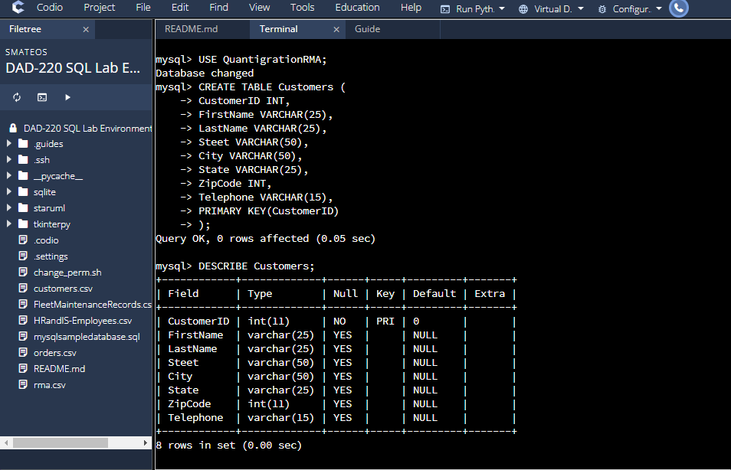

I create a table Customers in the QuantigrationRMA database. I add, columns, rows, and cells in the Customer Table.

* 1. A table named **orders** in the QuantigrationRMA database as defined on the project ERD. Provide the SQL commands you ran against MySQL to complete this successfully in your answer:

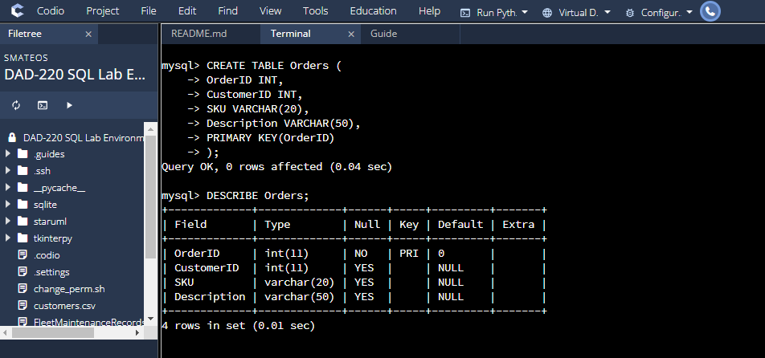

I create a table Orders in the QuantigrationRMA database. I add, columns, rows, and cells in the Orders Table.

* 1. 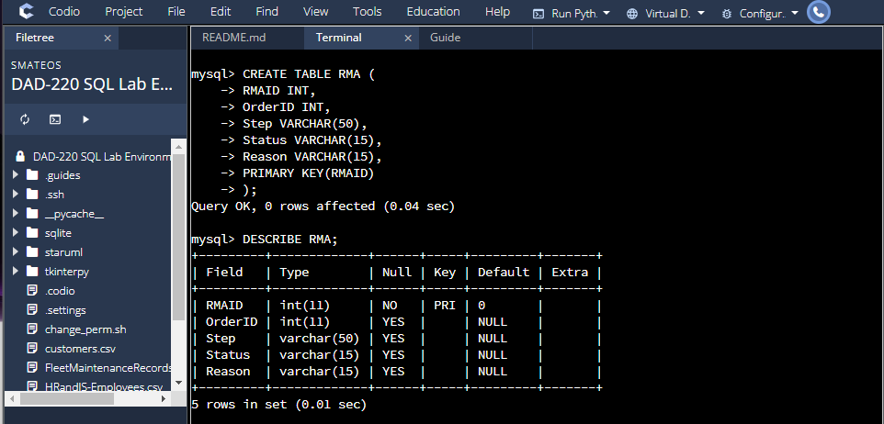A table named **rma** in the QuantigrationRMA database as defined on the project ERD. Provide the SQL commands you ran against MySQL to complete this successfully in your answer:

I create a table RMA in the QuantigrationRMA database. I add, columns, rows, and cells in the RMA Table.

1. Manually **add 10 records** into the **Customers table**. The data can be made up for now, as you you’ll populate all three tables later from the provided CSV files.

[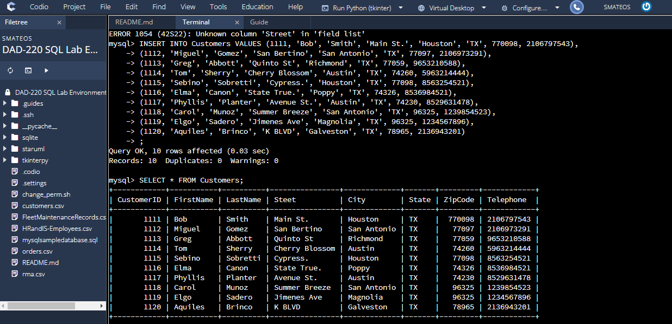

I insert 10 customers to the Customers database. First, I commit an error since I typed INSERT INTO Customers and I try to describe the table, but when I change to INSERT INTO Customers VALUES, I was able to add the new customers.

1. Create a view from the **existing Customers table** by using the SQL command provided belowto say "Collaborators." The view should show all instances of "Customer" renamed as "Collaborator."

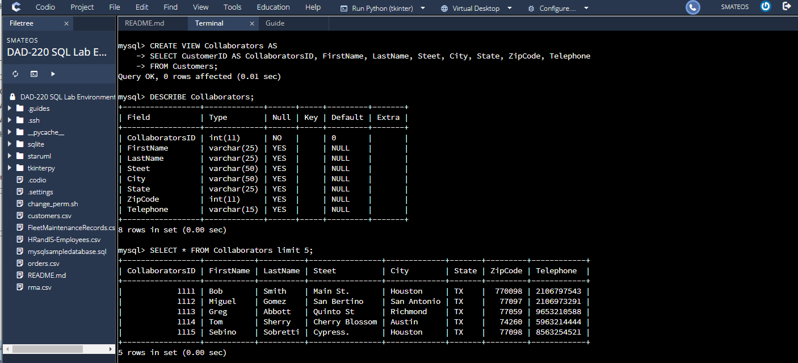

Based on the zyBook lecture I follow typed my commands. Frist I developed CREATE VIEW Collaborators AS to create a view.